SBT
# Source: AI Source: Provided by: [Data Path: Persons Table -> ID Column: 1, Name_En Column: Motasem Essam] -> From: [ChatGPT] on [1/26/2026]
SBT (Scala Build Tool) is the standard build tool for Scala projects. It manages compilation, testing, dependency management, and packaging, similar to Maven or Gradle for Java.
👉 Think of it like Make or Ant, but designed specifically for Scala projects.

⚙️ What SBT Does:
# Source: AI Source: Provided by: [Data Path: Persons Table -> ID Column: 1, Name_En Column: Motasem Essam] -> From: [ChatGPT] on [1/26/2026]
● Compiles Scala and Java source code
● Runs tests automatically
● Manages project dependencies and libraries
● Builds JAR files and packages applications
● Supports incremental compilation for faster builds

✅ Why Use SBT?
# Source: AI Source: Provided by: [Data Path: Persons Table -> ID Column: 1, Name_En Column: Motasem Essam] -> From: [ChatGPT] on [1/26/2026]
Feature Description
⚡ Incremental Compilation Recompiles only changed files
📦 Dependency Management Handles libraries via build.sbt
🔁 Automation Compile, test, run, and package tasks
🧠 Multi-Project Builds Supports complex, modular projects
🤝 Integration Works with popular Scala frameworks like Akka and Play

📄 build.sbt
# Source: AI Source: Provided by: [Data Path: Persons Table -> ID Column: 1, Name_En Column: Motasem Essam] -> From: [ChatGPT] on [1/26/2026]
build.sbt is the configuration file for SBT (Scala Build Tool). It defines your project settings, dependencies, and build instructions.
👉 Think of it like a Gemfile for Ruby or package.json for JavaScript, but for Scala projects.

⚙️ What build.sbt Contains:
# Source: AI Source: Provided by: [Data Path: Persons Table -> ID Column: 1, Name_En Column: Motasem Essam] -> From: [ChatGPT] on [1/26/2026]
● Project Name → The name of your project
● Version → Project version
● Scala Version → Scala compiler version to use
● Library Dependencies → External libraries or frameworks your project needs
● Build Settings → Additional configuration like compiler options, test frameworks, or packaging

✅ Example build.sbt
# Source: AI Source: Provided by: [Data Path: Persons Table -> ID Column: 1, Name_En Column: Motasem Essam] -> From: [ChatGPT] on [1/26/2026]
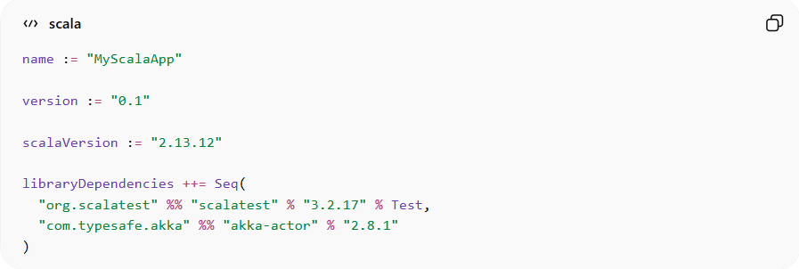
name := "MyScalaApp"

version := "0.1"

scalaVersion := "2.13.12"

libraryDependencies ++= Seq(
"org.scalatest" %% "scalatest" % "3.2.17" % Test,
"com.typesafe.akka" %% "akka-actor" % "2.8.1"
)

Explanation:
# Source: AI Source: Provided by: [Data Path: Persons Table -> ID Column: 1, Name_En Column: Motasem Essam] -> From: [ChatGPT] on [1/26/2026]
- name := "MyScalaApp" → Sets the project name
- version := "0.1" → Defines the project version
- scalaVersion := "2.13.12" → Uses Scala 2.13.12 for compilation
- libraryDependencies ++= Seq(...) → Adds external libraries:
  - %% ensures the Scala version matches
  - % Test indicates the dependency is only for testing

⚡ How build.sbt Works
# Source: AI Source: Provided by: [Data Path: Persons Table -> ID Column: 1, Name_En Column: Motasem Essam] -> From: [ChatGPT] on [1/26/2026]
- SBT reads the file when you run commands like sbt compile or sbt run
- Downloads libraries automatically from Maven repositories
- Configures the build according to the defined settings
- Supports incremental compilation for faster builds

⚠️ Important Notes
# Source: AI Source: Provided by: [Data Path: Persons Table -> ID Column: 1, Name_En Column: Motasem Essam] -> From: [ChatGPT] on [1/26/2026]
• Must be named exactly build.sbt in the project root
• Supports Scala DSL, so you can add variables, conditions, and tasks
• Always keep it under version control with your project

🧠 Quick Summary
# Source: AI Source: Provided by: [Data Path: Persons Table -> ID Column: 1, Name_En Column: Motasem Essam] -> From: [ChatGPT] on [1/26/2026]
build.sbt = Build configuration for Scala projects
✔ Defines project name, version, and Scala version
✔ Manages dependencies and libraries
✔ Used by SBT to automate compilation, testing, and packaging

▶️ Common SBT Commands
# Source: AI Source: Provided by: [Data Path: Persons Table -> ID Column: 1, Name_En Column: Motasem Essam] -> From: [ChatGPT] on [1/26/2026]
📥 Install dependencies & compile:
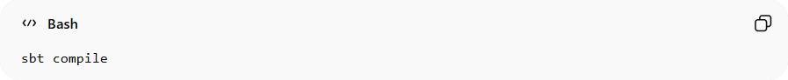
sbt compile
🎯 Run project:
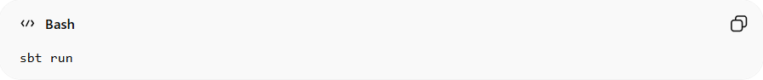
sbt run
🔄 Run tests:
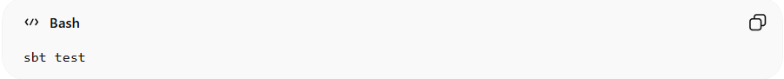
sbt test
📦 Build JAR:
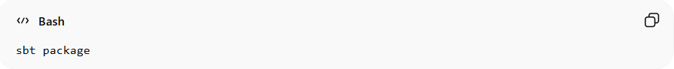
sbt package

📁 How SBT Works
# Source: AI Source: Provided by: [Data Path: Persons Table -> ID Column: 1, Name_En Column: Motasem Essam] -> From: [ChatGPT] on [1/26/2026]
- Reads build.sbt file for project info
- Resolves and downloads dependencies
- Compiles only changed files (incremental compilation)
- Runs tasks like tests or packaging
👉 Makes Scala project development faster and organized

⚠️ Limitations of SBT
# Source: AI Source: Provided by: [Data Path: Persons Table -> ID Column: 1, Name_En Column: Motasem Essam] -> From: [ChatGPT] on [1/26/2026]
• Can be slow to start for large projects
• Learning curve for new Scala developers
• Configuration syntax can be confusing at first
• Not as widely used outside Scala ecosystem

🧠 SBT vs Maven/Gradle
# Source: AI Source: Provided by: [Data Path: Persons Table -> ID Column: 1, Name_En Column: Motasem Essam] -> From: [ChatGPT] on [1/26/2026]
Feature Maven/Gradle SBT
Language XML/Groovy Scala DSL
Dependency Management Yes Yes
Incremental Compilation Limited ✅ Yes
Scala Focus No ✅ Primary focus
Build Speed Moderate Faster for Scala projects

🧠 Quick Summary
# Source: AI Source: Provided by: [Data Path: Persons Table -> ID Column: 1, Name_En Column: Motasem Essam] -> From: [ChatGPT] on [1/26/2026]
SBT = Scala Build Tool
✔ Automates compilation, testing, and packaging
✔ Manages dependencies with build.sbt
✔ Optimized for Scala development and incremental builds

